ASSIGNMENT 10.6

1.Write a pig script to find the minimum temperature observed in a given weather station in a particular year.

CODE :

A = LOAD ‘/home/acadgild/Temperature.csv’ USING PigStorage(‘,’) AS (WeatherStation:chararray, date:int, type:chararray, temp:int);

B = FOREACH A generate WeatherStation,date/10000 as year,temp;

C = GROUP B by (WeatherStation,year);

D = FOREACH C generate group,MIN(B.temp);

DUMP D;

OUTPUT :

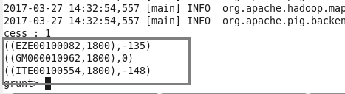

2. Write a pig script to find the maximum temperature observed in a given weather station in a particular year.

A = LOAD ‘/home/acadgild/Temperature.csv’ USING PigStorage(‘,’) AS (WeatherStation:chararray, date:int, type:chararray, temp:int);

B = FOREACH A generate WeatherStation,date/10000 as year,temp;

C = GROUP B by (WeatherStation,year);

D = FOREACH C generate group,MAX(B.temp);

DUMP D;

OUTPUT :

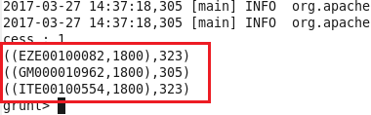

3. Write a pig script to find the number of readings given by each weather station according to the dataset.

CODE :

A = LOAD ‘/home/acadgild/Temperature.csv’ USING PigStorage(‘,’) AS (WeatherStation:chararray, date:int, type:chararray, temp:int);

B = FOREACH A generate WeatherStation,date/10000 as year,temp;

C = GROUP B by WeatherStation;

D = FOREACH C generate group,COUNT(B.temp);

DUMP D;

OUTPUT :

